WEEK 2- DAY 2

S01-Text to Audio

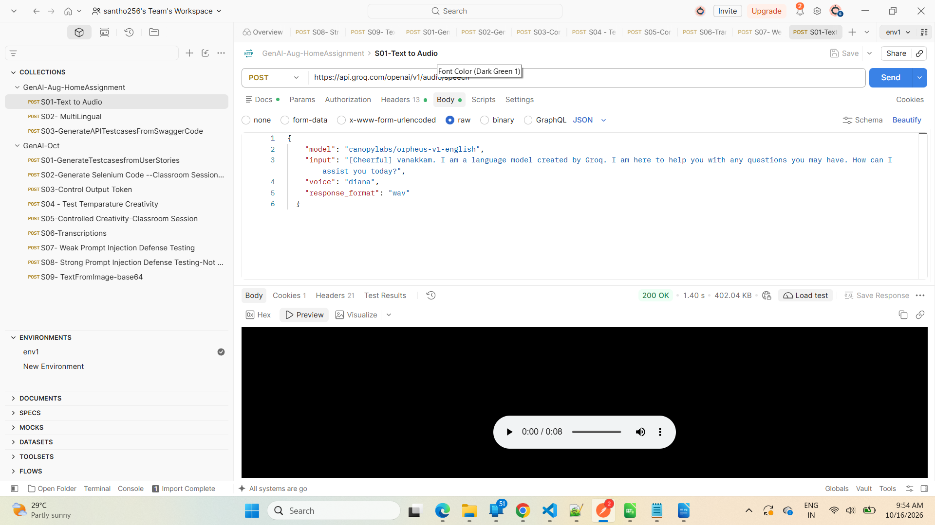
S02- MultiLingual

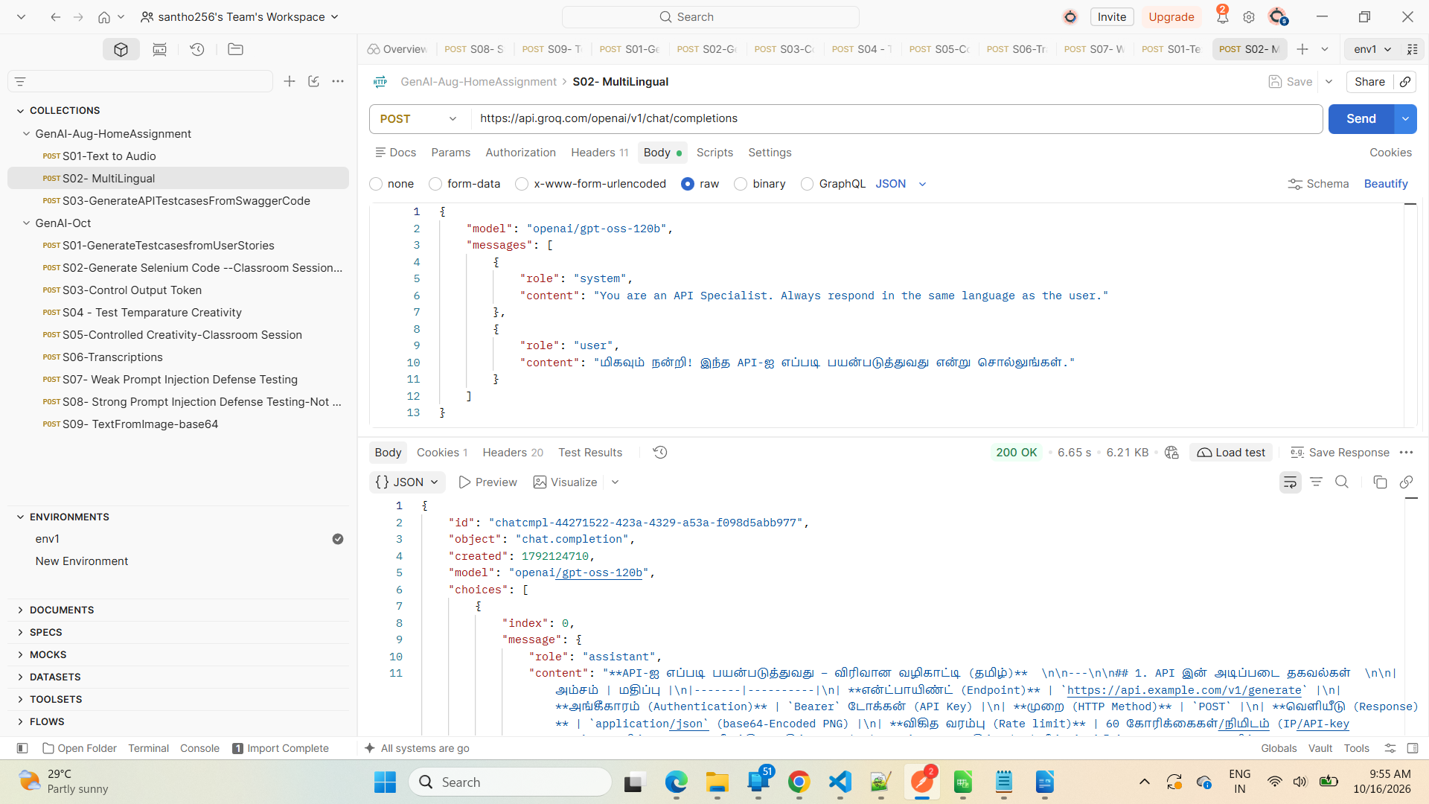

S03-GenerateAPITestcasesFromSwaggerCode

